1.22

Pre-open

Futures crashed in pre-open confusion. Index down -0.4%.

Close:

1.23

PM stock trading proved to be effective, keep trading this way.

Morning panics (Huada Jiyin) are not as reliable as PM pickup.

Improving on:

Futures intraday vegetable trading. Use 1/3 position keep accu/decu. Eager accumulation and dissemination, aim at 0.3% swings.

Key to returns that beat the market

1. Intraday vegetable trading. Aim at 30 bps movements with 1/3 position. Reason for 1/3: you need to have 1/3 as base mtm position and 1/3 to add in case closes at the lows.
2. PMCL. With pmcoY support, you can add on unrealized profit, dissemination at close. With no pmcoY support, add only at PM low, eager dissemination.

Key to stock outperformance

1. Opening panic following a low closer
2. Accumulate on PM lows. Sell the next day at highs. Follow 2-2-2 principle. If two days consecutively lose, trade next week, if two weeks loss, trade next month. If two months loss, then cut position.
3. Aim at 1%~2% return on these strategies. Use 10% portfolio (currently 250k), should contribute to about 10 bps ~ 20bps.
4. Pick long term stable/upward stocks, camp in low closers where day traders lost money. If others haven’t lost money, no entrance.

1.25.2018

Intraday tasks to execute key strategies

1. Futs: automatic accumulation, lowest percentile, accumulate/decumulate mode (toggle on/off), accumulation limit, eager/non eager.
2. Stock: crashing stocks/PM 0 perc. 冲落折(HO-DD/Range), 冲落差(HO-DD), 上冲落折,

Intraday vol is big, with stocks tanking deep and pulling back up.

No rush trading, wait until stabilizing.

Wed trend pnl was negative, thurs trend pnl follows suit.

1.26

Start trading 1/3 position.

Trend pnl is negative now, sell some during confusion.

Weekly recap:

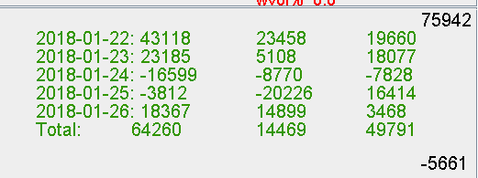

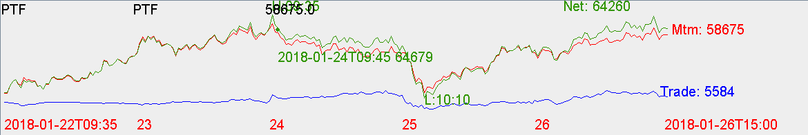

Big crash on thurs AM hurts confidence.

Thurs PM PD trading was good, keep honing fut veggie trading skills.

Can be aggressive following panic days.

1.27.2018 recap

Stock position too full, cannot do intraday trading. This is a negative.

Need about 25%~50% position allocated to intraday trading. (25% might be suitable @ 600k)

Other:

Feb fut is @ 30 bps premium. Jan fut expires on Jan 30. (Next tue)

Observation:

Liquidation in Dec cost 200k. In liquidation it is a chance to buy instead of sell from a long term perspective. Stocks sold in Dec on average rose 20% in Jan.

Lower a bit of position to be resilient to temporary shake-ups. Hold about 70% is fine. Use the rest to trade swing.

Banks are still undervalued and cheap.